Packet Tracer - Configuring IPv4 Route Summarization - Scenario 2

1. Topology

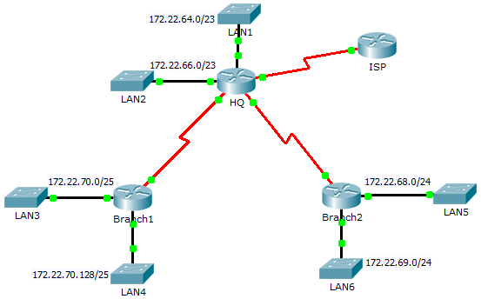

1. Addressing Table

|  |  |  |  |  |
| --- | --- | --- | --- | --- |
| Device | Interface | IPv4 Address | Subnet Mask | Default Gateway |
| ISP | S0/0/1 | 198.0.0.1 | 255.255.255.252 | N/A |
| HQ | G0/0 | 172.22.64.1 | 255.255.254.0 | N/A |
| G0/1 | 172.22.66.1 | 255.255.254.0 | N/A |
| S0/0/0 | 172.22.71.1 | 255.255.255.252 | N/A |
| S0/0/1 | 172.22.71.5 | 255.255.255.252 | N/A |
| S0/1/0 | 198.0.0.2 | 255.255.255.252 | N/A |
| Branch1 | G0/0 | 172.22.70.1 | 255.255.255.128 | N/A |
| G0/1 | 172.22.70.129 | 255.255.255.128 | N/A |
| S0/0/0 | 172.22.71.2 | 255.255.255.252 | N/A |
| Branch2 | G0/0 | 172.22.68.1 | 255.255.255.0 | N/A |
| G0/1 | 172.22.69.1 | 255.255.255.0 | N/A |
| S0/0/1 | 172.22.71.6 | 255.255.255.252 | N/A |
| LAN1 | VLAN 1 | 172.22.64.2 | 255.255.254.0 | 172.22.64.1 |
| LAN2 | VLAN 1 | 172.22.66.2 | 255.255.254.0 | 172.22.66.1 |
| LAN3 | VLAN 1 | 172.22.70.2 | 255.255.255.128 | 172.22.70.1 |
| LAN4 | VLAN 1 | 172.22.70.130 | 255.255.255.128 | 172.22.70.129 |
| LAN5 | VLAN 1 | 172.22.68.2 | 255.255.255.0 | 172.22.68.1 |
| LAN6 | VLAN 1 | 172.22.69.2 | 255.255.255.0 | 172.22.69.1 |

1. Objectives

Part 1: Calculate Summary Routes

Part 2: Configure Summary Routes

Part 3: Verify Connectivity

1. Background

In this activity, you will calculate and configure summary routes. Route summarization, also known as route aggregation is the process of advertising a contiguous set of addresses as a single address. After calculating summary routes for each LAN, you must summarize a route that includes all networks in the topology for the ISP to reach each LAN.

1. Calculate Summary Routes
   * 1. What is the summary route to reach HQ LANs? ______________________________________________
     2. What is the summary route to reach Branch1 LANs? __________________________________________
     3. What is the summary route to reach Branch2 LANs? __________________________________________
     4. What is the summary route from the ISP router to reach all LANs? _______________________________
2. Configure Summary Routes
   1. Configure the summary routes on the HQ router to other networks.
      1. Configure a directly attached summary route on **HQ** to reach the **Branch1** LANs.
      2. Configure a recursive summary route on **HQ** to reach the **Branch2** LANs.
   2. Configure the summary routes on the Branch1 router to other networks.
      1. Configure a recursive summary route on **Branch1** to reach the **HQ** LANs.
      2. Configure a recursive summary route on **Branch1** to reach the **Branch2** LANs.
   3. Configure the summary routes on the Branch2 router to other networks.
      1. Configure a directly attached summary route on **Branch2** to reach the **Branch1** LANs.
      2. Configure a recursive summary route on **Branch2** to reach the **HQ** LANs.
   4. Configure a summary route on ISP to reach all networks.
3. Verify Connectivity

Verify that all switches and routers can ping other devices in the topology. If not, troubleshoot your summary routes to correct any issues.